**Ref. No. MES IMCC / 198/ 2024 – 25 Date:04/04/2025**

**CERTIFICATE**

This is to certify that the Project entitled **“TaxQueryAI**“ is completed by **“Pratyush Prakash Majumdar**” of M.C.A. Semester II for the Academic Year 2024-25 at MES’ Institute of Management & Career Courses (IMCC), Pune - 411038.

To the best of our knowledge, this is an original study done by the said student and important sources used by him/her have been duly acknowledged in this report.

The report is submitted as a part of course ITP21 Mini Project for the Academic Year 2024-25 as per the rules and guidelines prescribed by the institute.

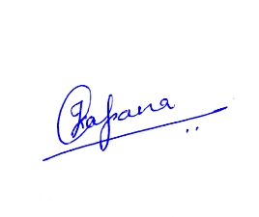  

Ms. Kalpana Dhende Ms. Manasi Shirurkar Dr. Ravikant Zirmite

Project Coordinator Program Coordinator Head, Dept. Of MCA

**Ref. No. MES IMCC / 198/ 2024 – 25 Date:04/04/2025**

**CERTIFICATE**

This is to certify that the Project entitled **“TaxQueryAI**“ is completed by **“Varad Vivek Pandit**” of M.C.A. Semester II for the Academic Year 2024-25 at MES’ Institute of Management & Career Courses (IMCC), Pune - 411038.

To the best of our knowledge, this is an original study done by the said student and important sources used by him/her have been duly acknowledged in this report.

The report is submitted as a part of course ITP21 Mini Project for the Academic Year 2024-25 as per the rules and guidelines prescribed by the institute.

  

Ms. Kalpana Dhende Ms. Manasi Shirurkar Dr. Ravikant Zirmite

Project Coordinator Program Coordinator Head, Dept. Of MCA

**Synopsis**

**Product Functions/Modules**

1. **Core Functionality:** TaxQueryAI allows tax officials to ask questions directly in natural language, which are then converted to SQL queries using LangChain. These queries are executed on a MySQL database containing property tax records from seven Indian cities (Pune, Solapur, Chennai, Erode, Jabalpur, Thanjavur, and Tiruchirappalli) for the years 2013 to 2018. The results are returned as easy-to-understand answers, removing the need for manual database access or technical expertise.
2. **Chatbot Module**: The system includes a 24/7 AI-powered chatbot that responds to various tax-related queries, providing continuous support to users and helping them retrieve insights on-demand.
3. **Analytics Dashboard**: An interactive dashboard presents visual insights such as city-wise tax collections, collection gaps, and property-type efficiencies using various charts. This helps tax officials understand trends at a glance.
4. **Prediction Module**: A forecasting system predicts future property tax trends using machine learning models. These predictions are visualized to assist in planning and policy-making.

1. **Data Pipeline**: The data cleaning and processing pipeline is built on Azure services. Azure Data Factory handles ETL workflows, Azure Databricks transforms and cleans the data, and Azure Data Lake stores both raw and processed datasets for use within the system.
2. **Frontend**: The user interface is built using Next.js and hosted on Vercel, offering a smooth and responsive web experience for interacting with the chatbot and analytics features.
3. **Backend**: The backend is developed in Python using Flask and Streamlit, with LangChain integrated for natural language processing and MySQL as the main database.

**Users of system**

1. **Government tax officials:** They can query historical data, analyze performance, and use predictive insights for planning and auditing purposes.
2. **City Administrators / Officers:** They can monitor performance, compare trends across cities or years, and generate visual reports for internal decision-making.

**Use Case Diagram**

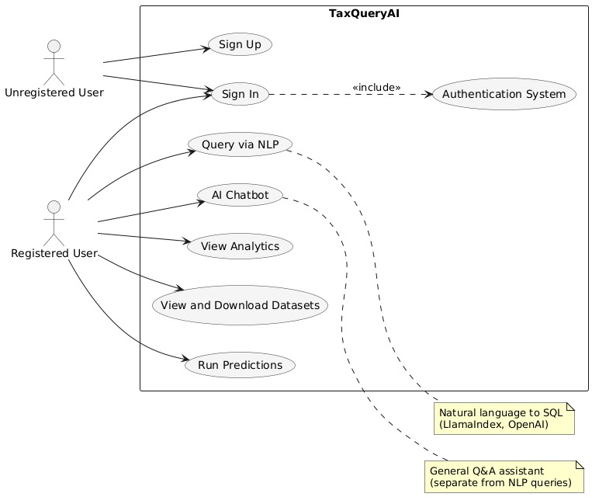

**Snapshots**

1. Home page

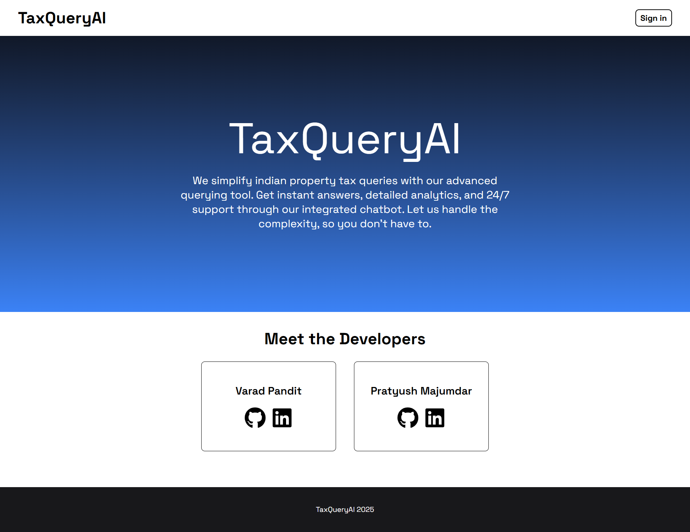

1. Sign-in page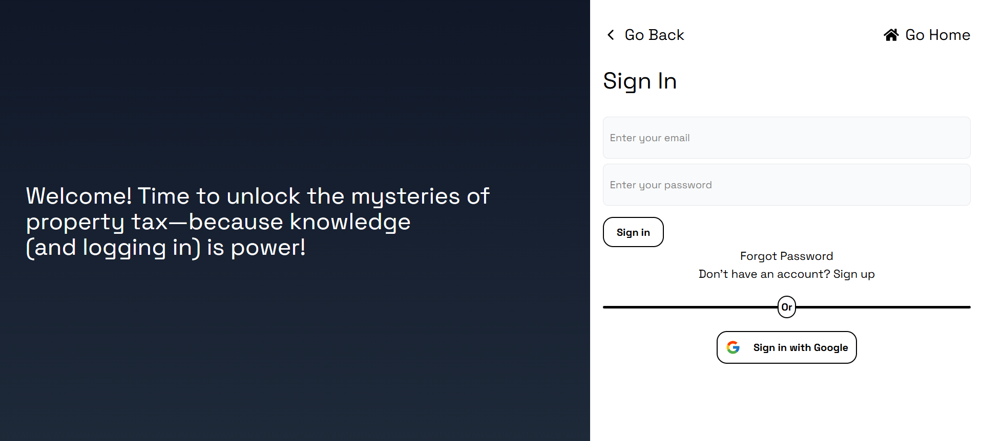

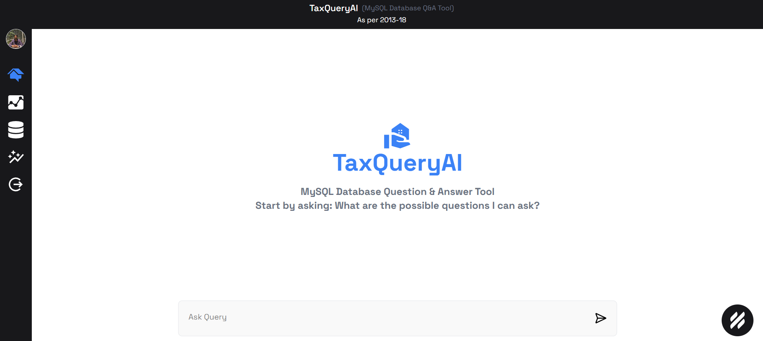 3) User interaction page

4) User query and response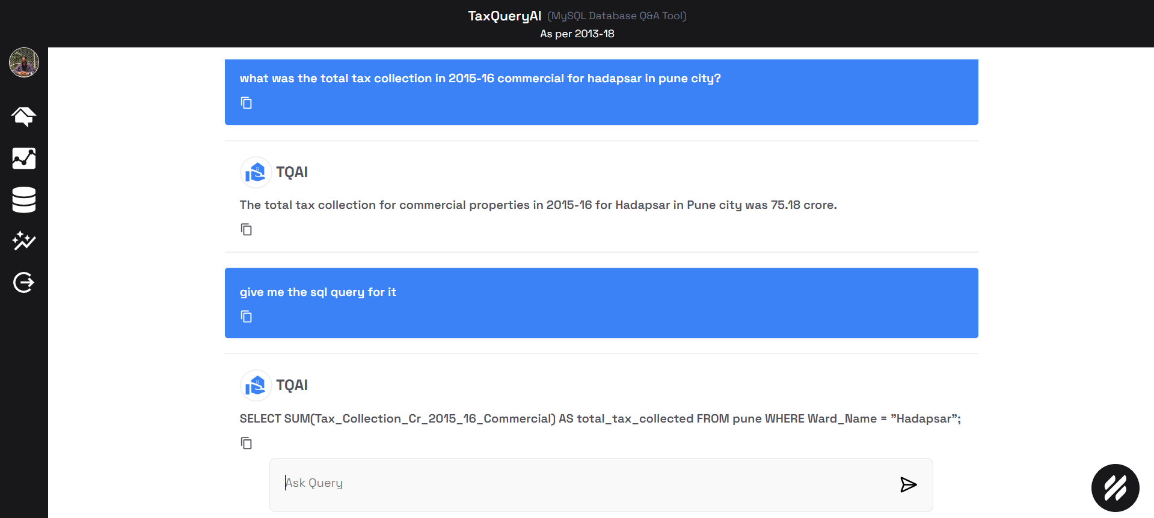

1. 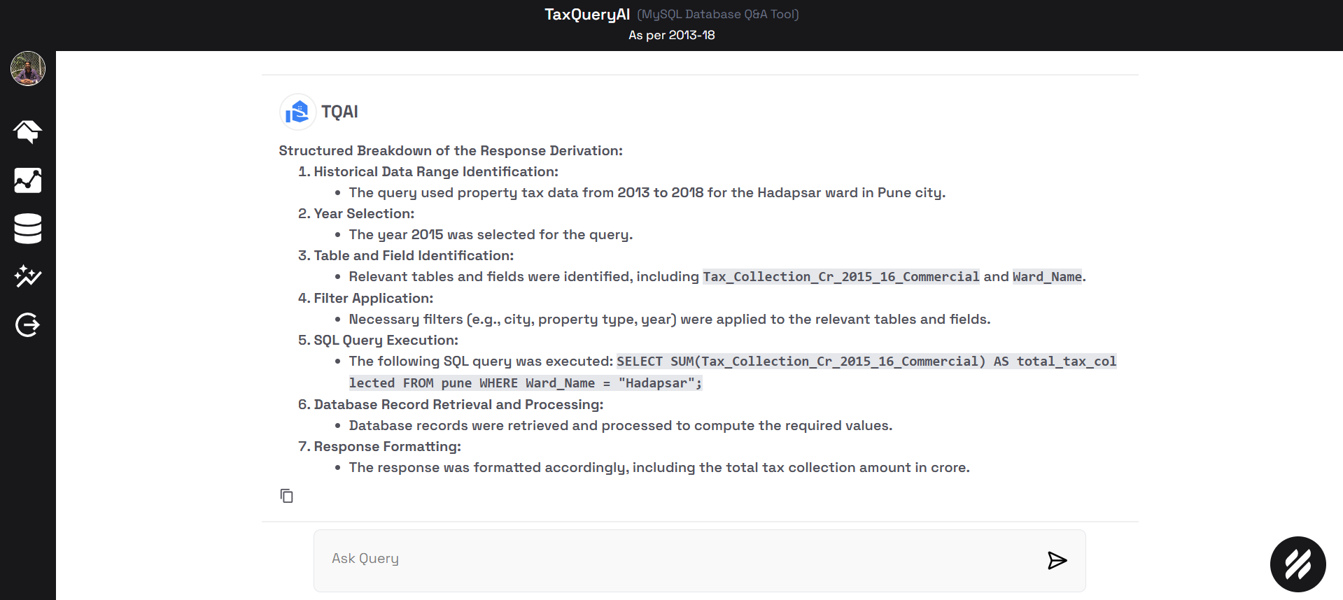Breakdown of the response

1. 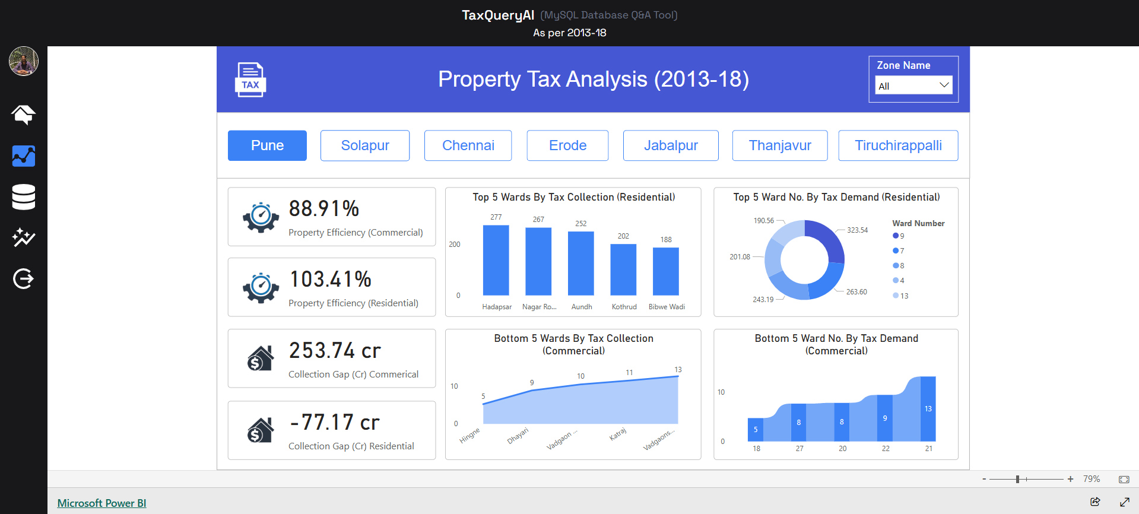Analytics dashboard
2. 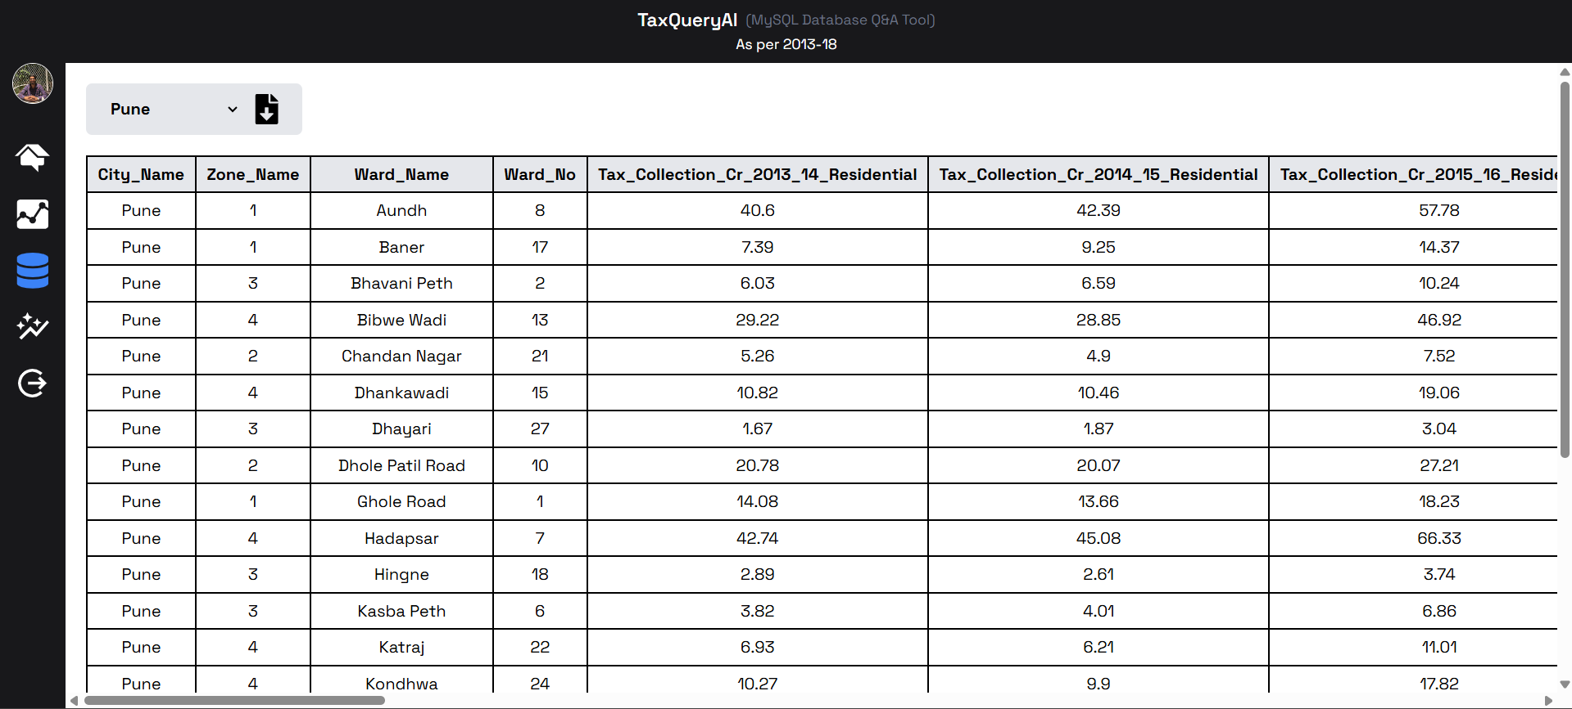Datasets
3. 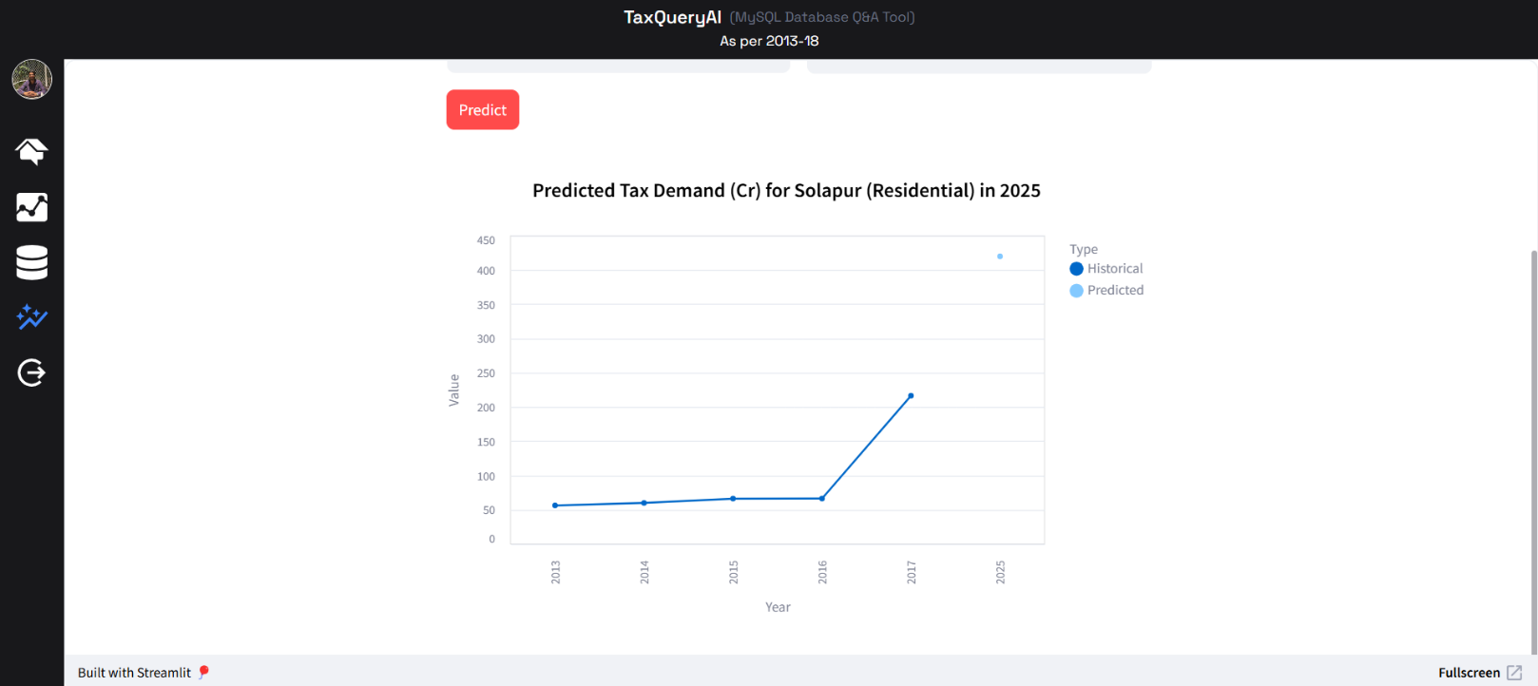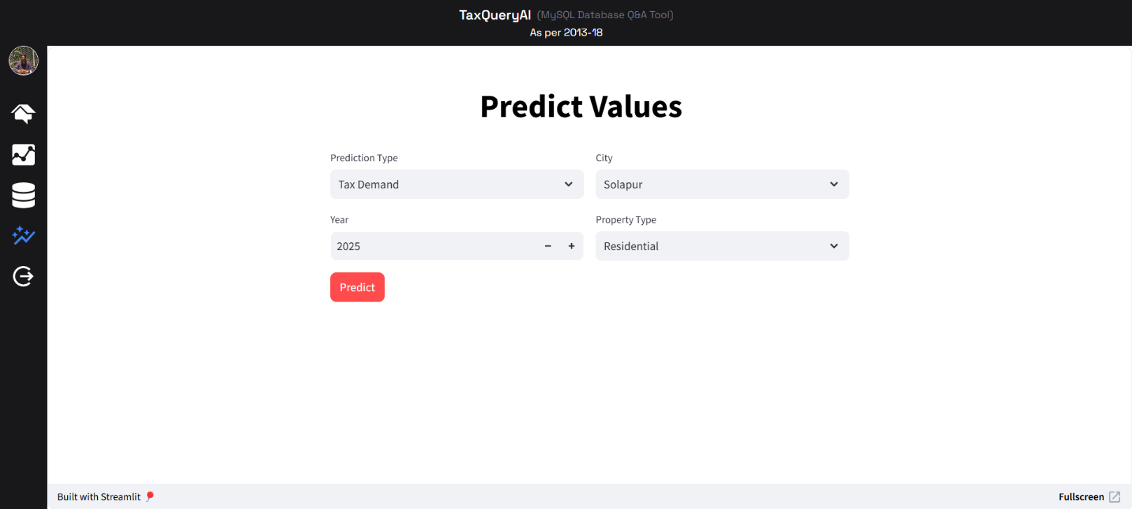Predict and visualize

9) Chatbot

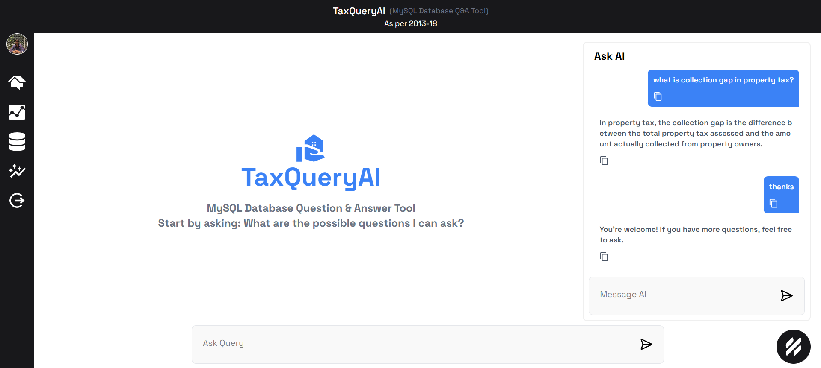

10) Stored user responses

